K200340 Sarosh Jawed

K200380 Hassan Malik

K200383 Eisha Fatima

BSCS-4F

K18-0222 Abdul Rafay Tariq 2-H

NUMERICAL COMPUTING PROJECT

# Introduction:

In this project user is prompted to select a certain method by the program and then asked to input all required data which will result in solution of required method.

# Methods implemented:

Methods implemented are as follows:

1. Solutions of Nonlinear Equations in One Variable
   1. Bisection Method
   2. Fixed Point Method
   3. Newton Method
   4. Regula Falsi Method
   5. Secant Method
2. Interpolation and Polynomial Approximation
   1. Divided Difference Tables (Forward Difference, Backward Difference and Divided Difference)
   2. Lagrange’s Method
   3. Strilling Formula (Central Difference)
3. Solution of Ordinary Differential Equations
   1. Euler’s Method
   2. 4RK Method
   3. Heun’s Method

# Algorithms:

# Solutions of Non-Linear Equations in One Variable

# Bisection method:

# 

# Fixed Point Method

# 

# 

# 

# 

# 

# Newton’s Method

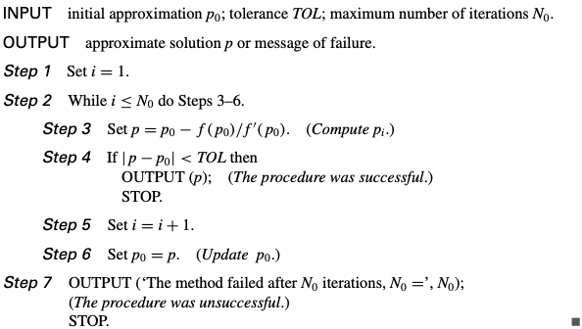

# Regula Falsi Method

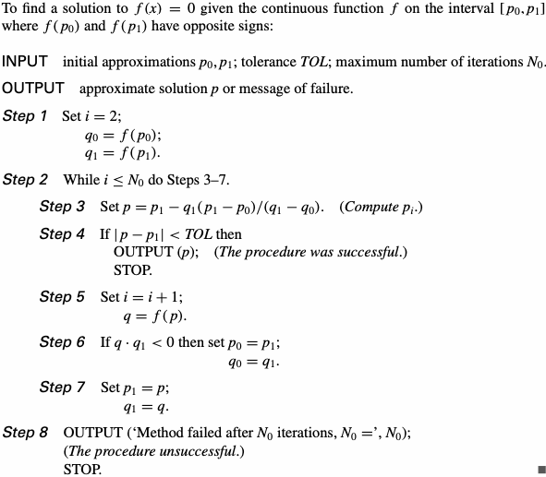

# Secant Method

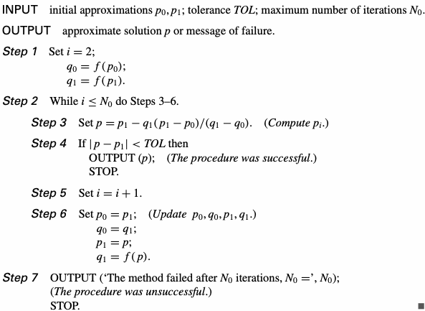

# Interpolation and Polynomial Approximation

# Lagrange’s Polynomial upto the 5th degre

# 2. DIVIDED DIFFERENCE TABLES

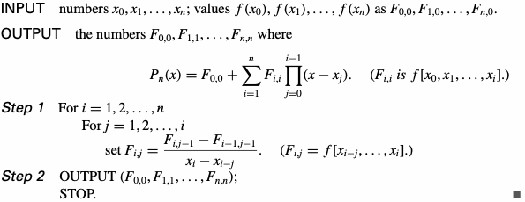

# Newton Forward Difference Formula

# 

# Newton Backward Difference Formula



# CENTERED DIFFERENCES

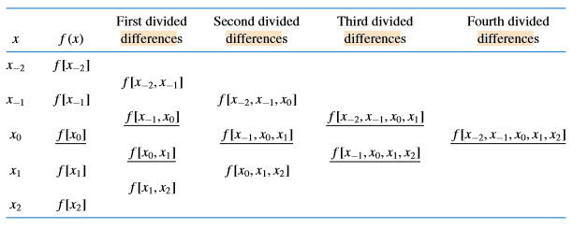

# Numerical Differentiation and Integration

# 

# Euler’s Method:

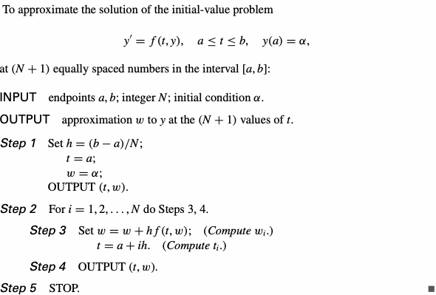

# 4RK Method:

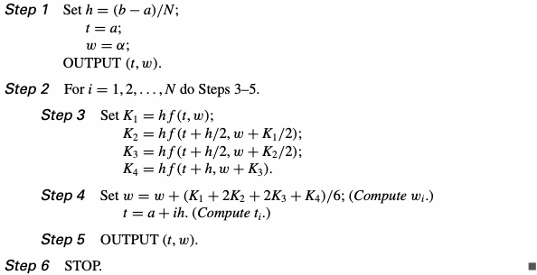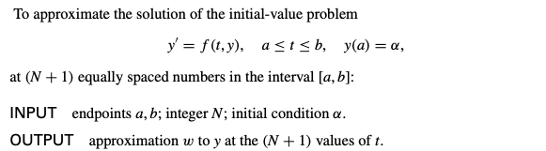

# Heun’s Method:

# 

# Codes:

Lab 1:

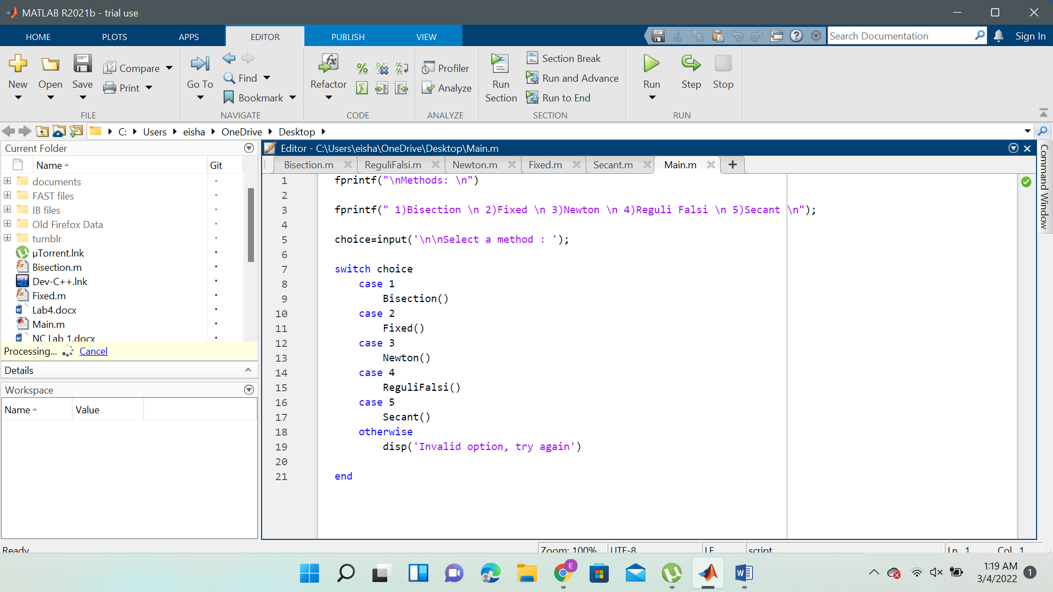

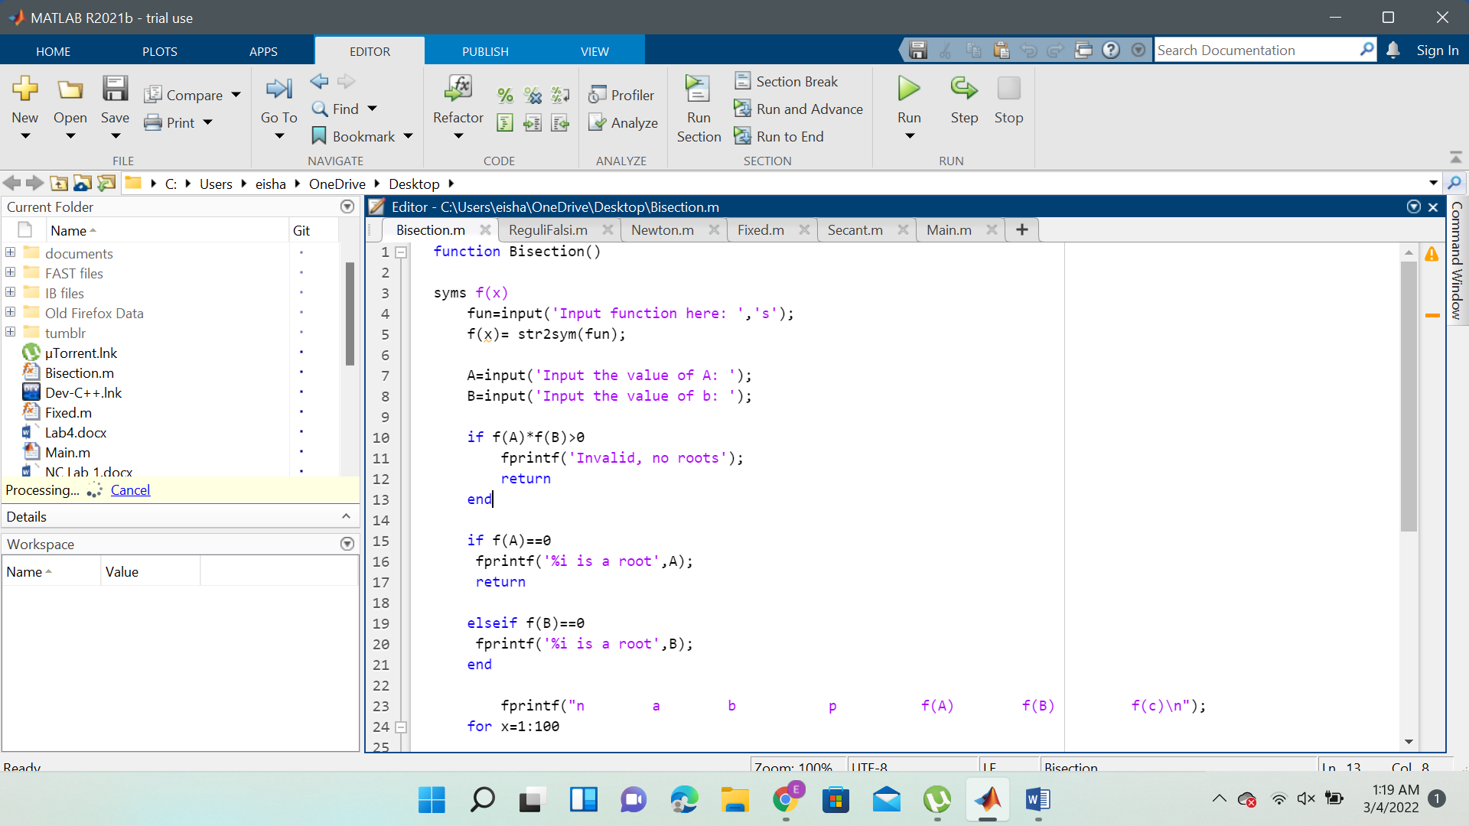

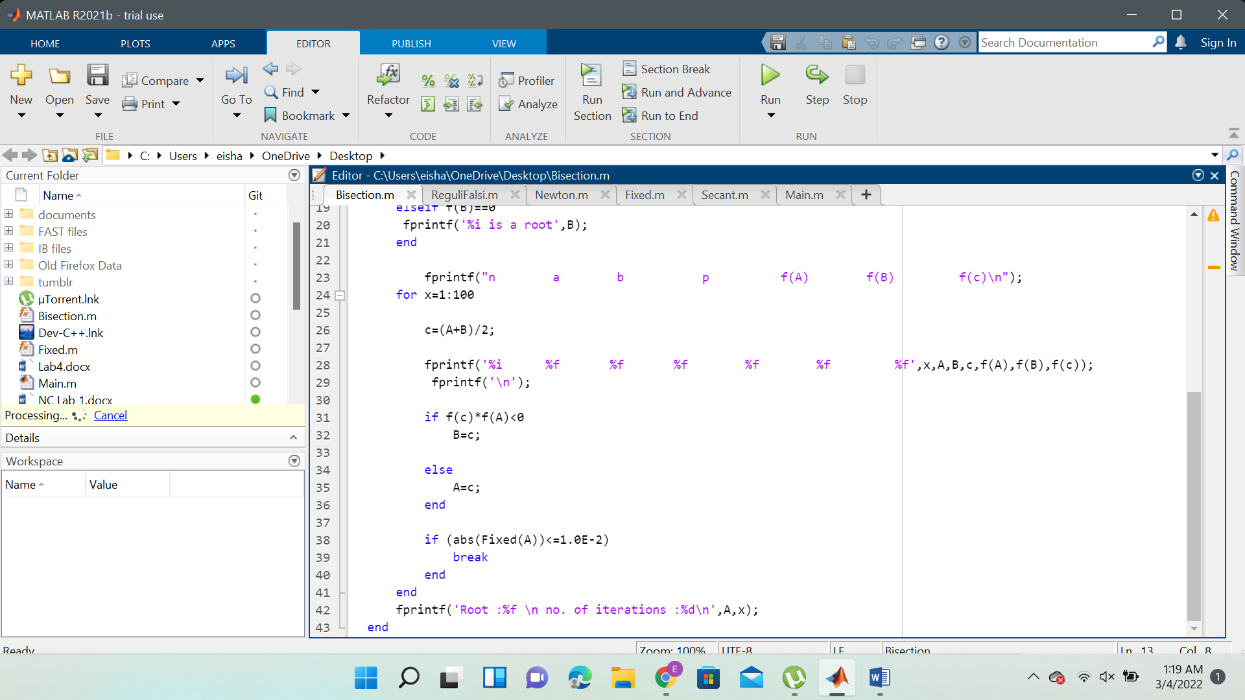

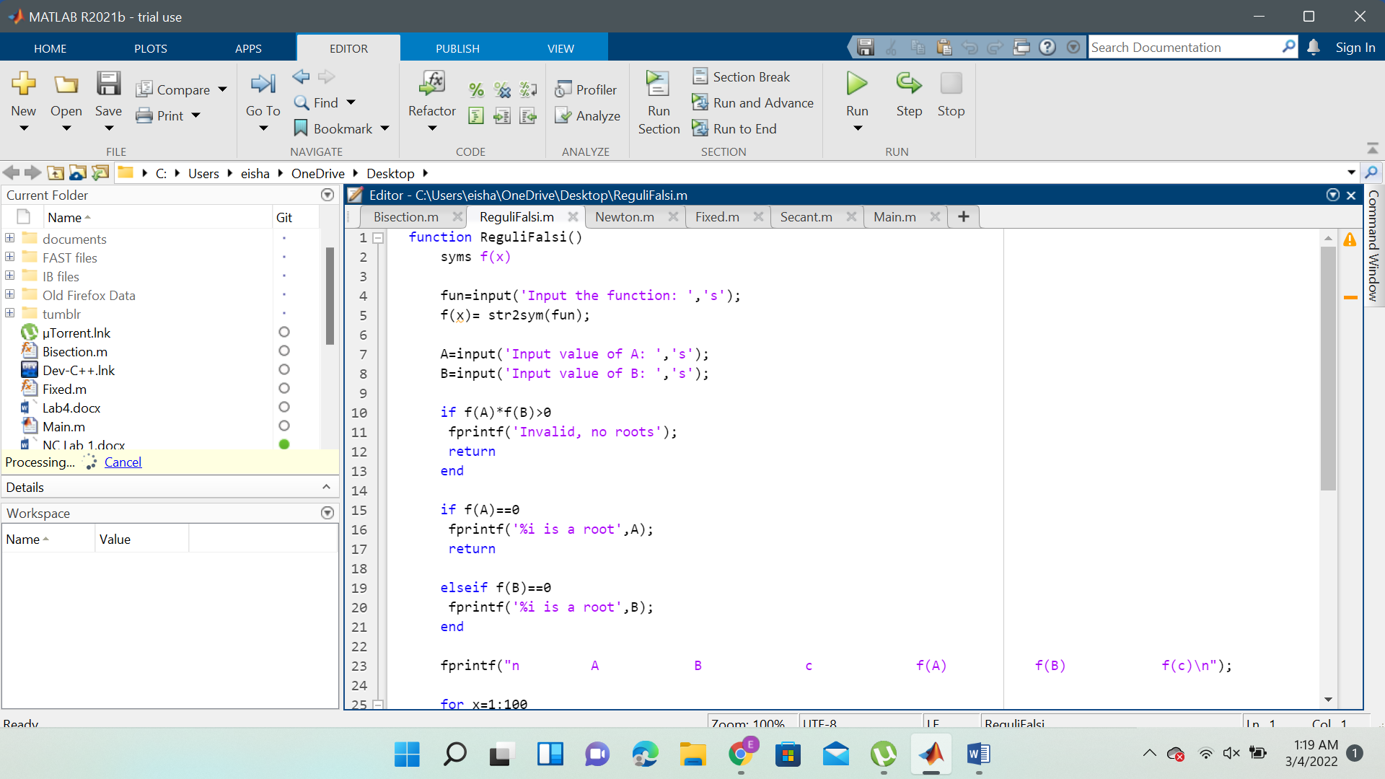

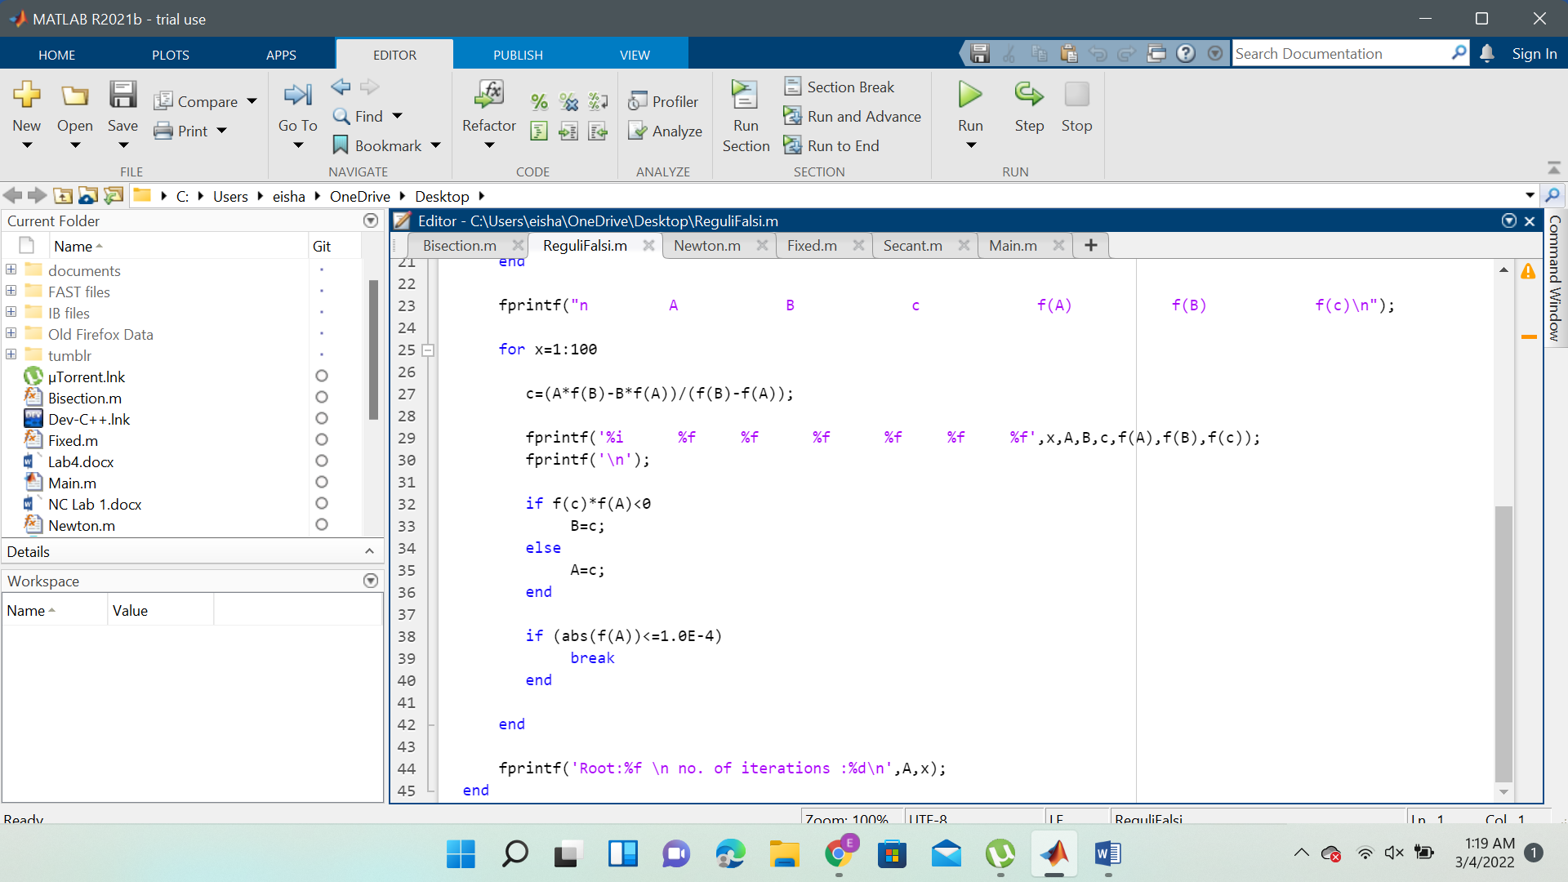

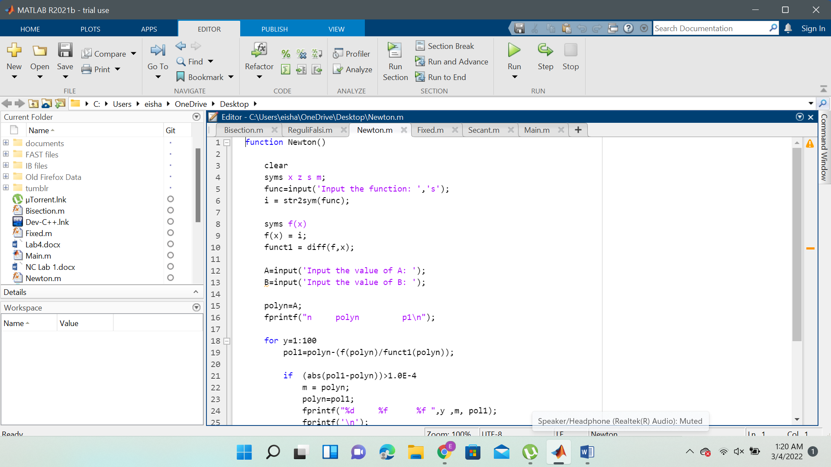

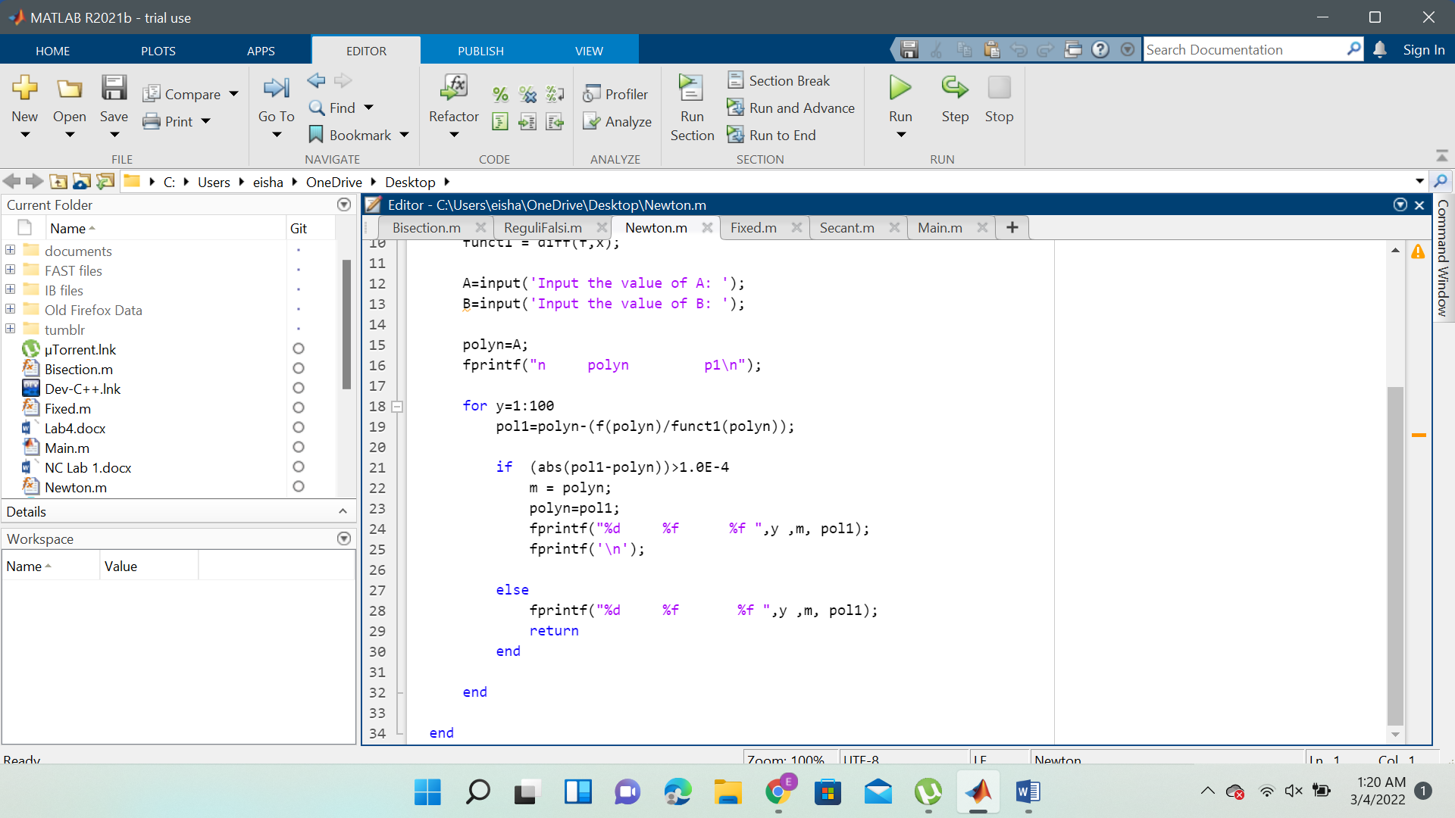

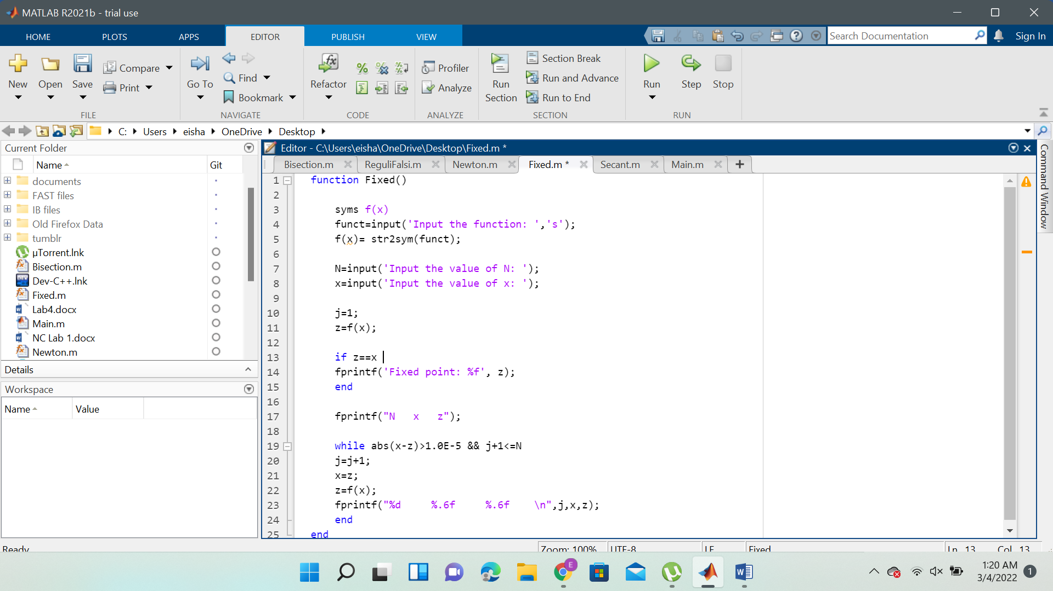

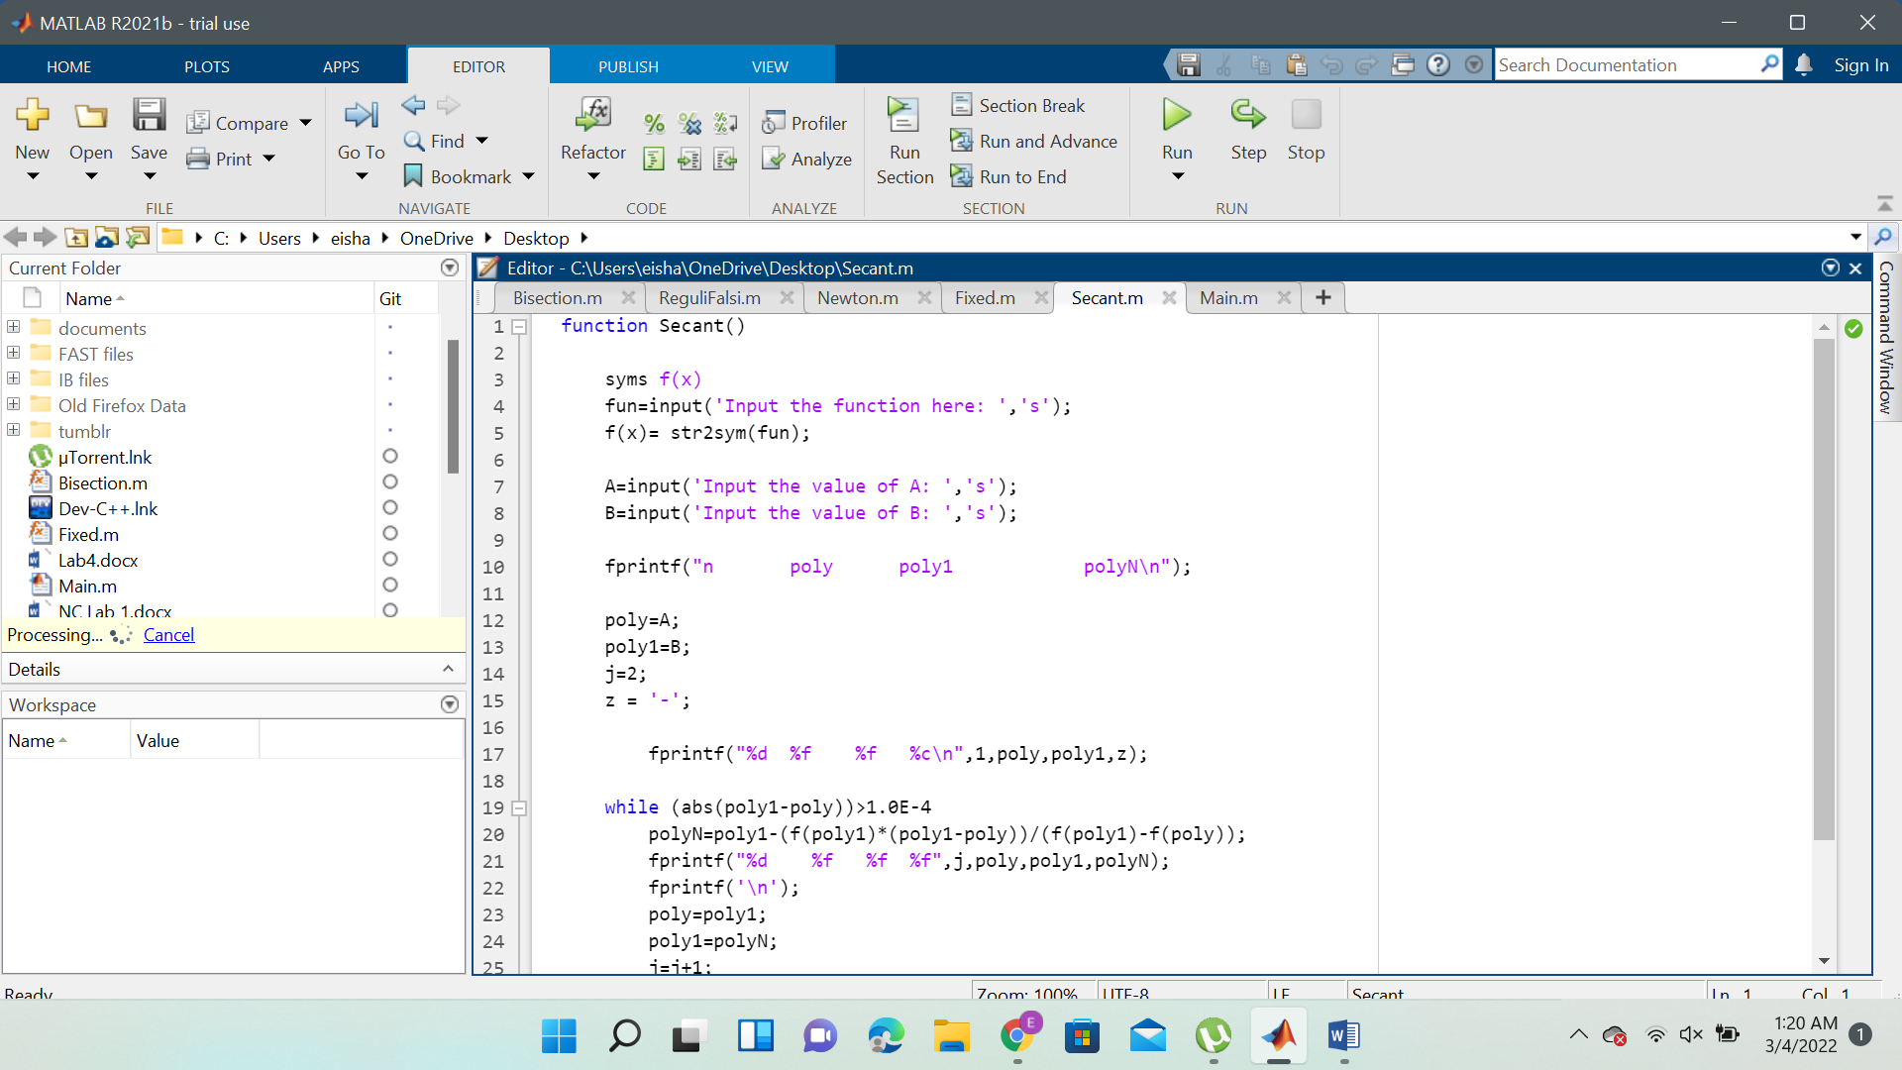

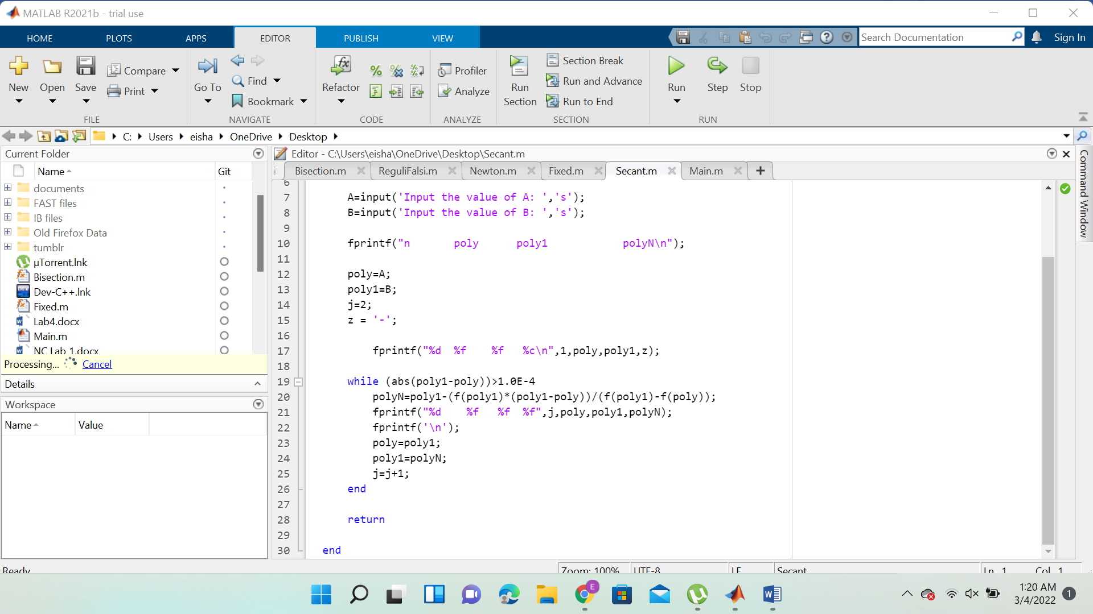

Lab 2:

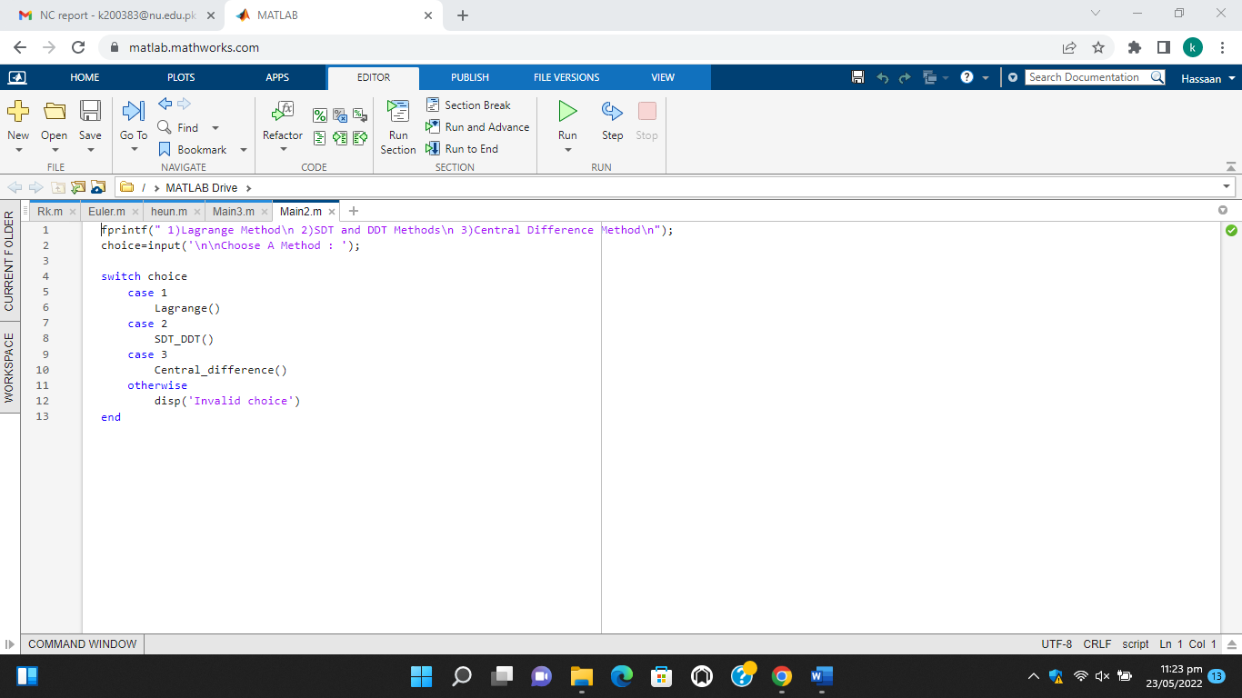

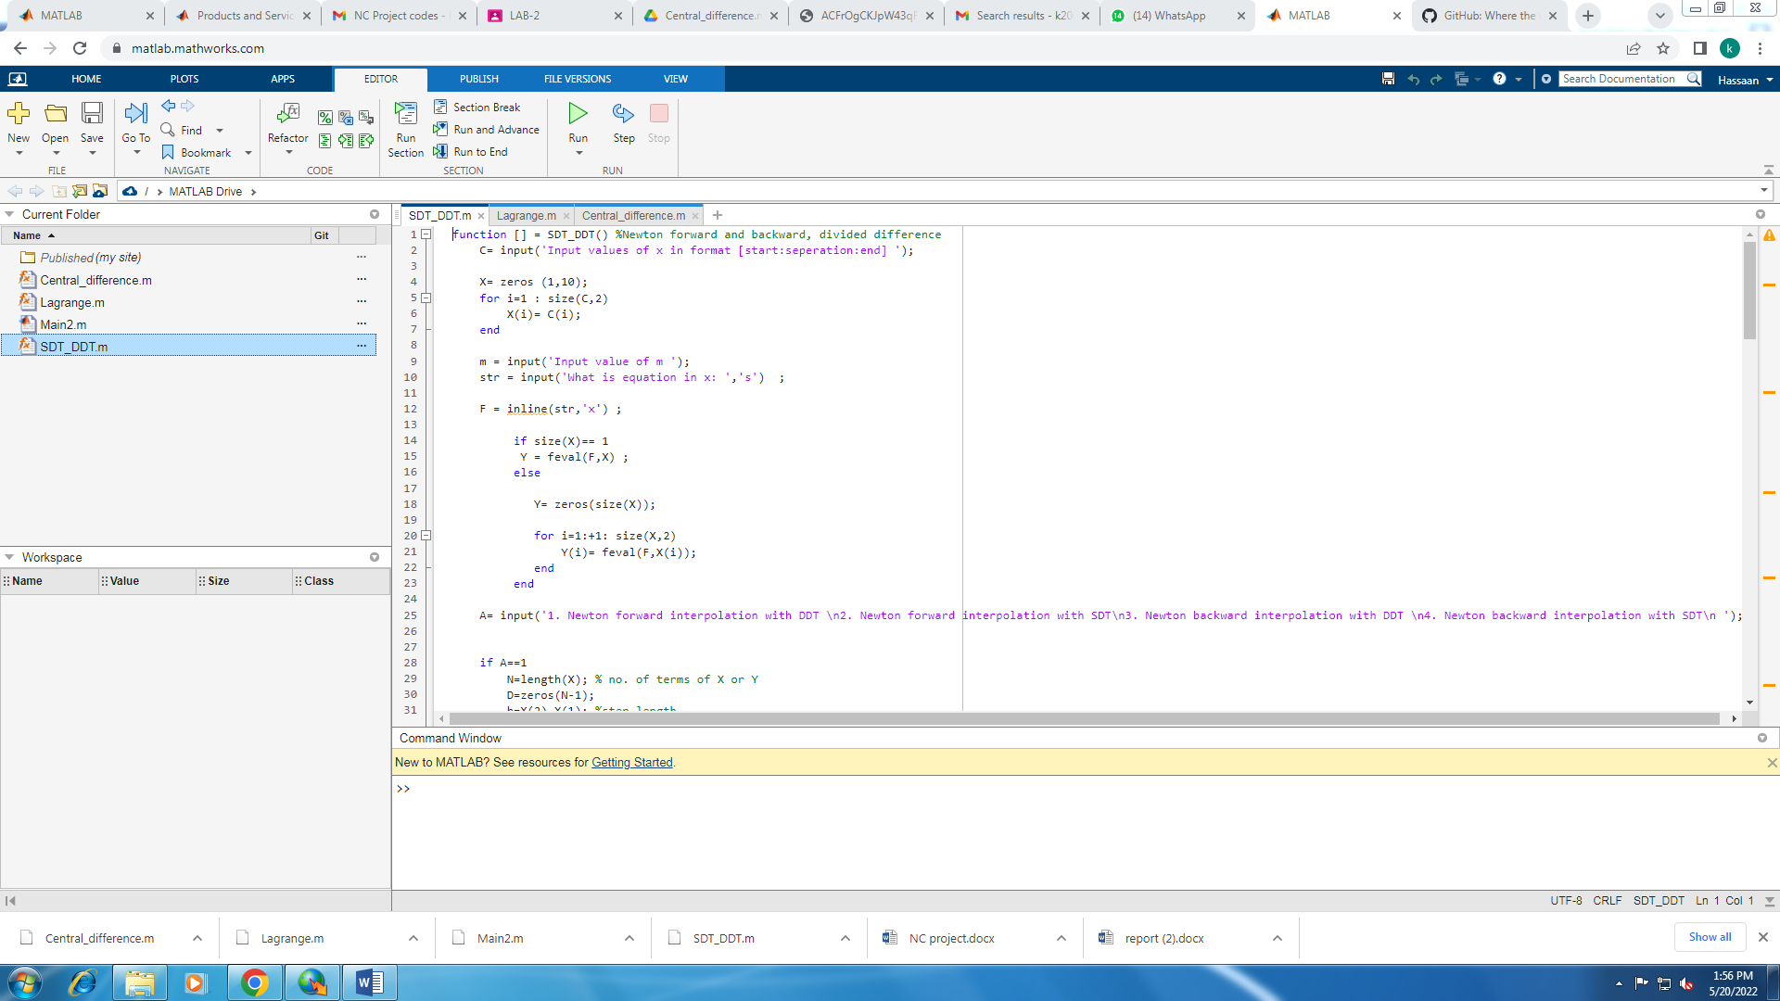

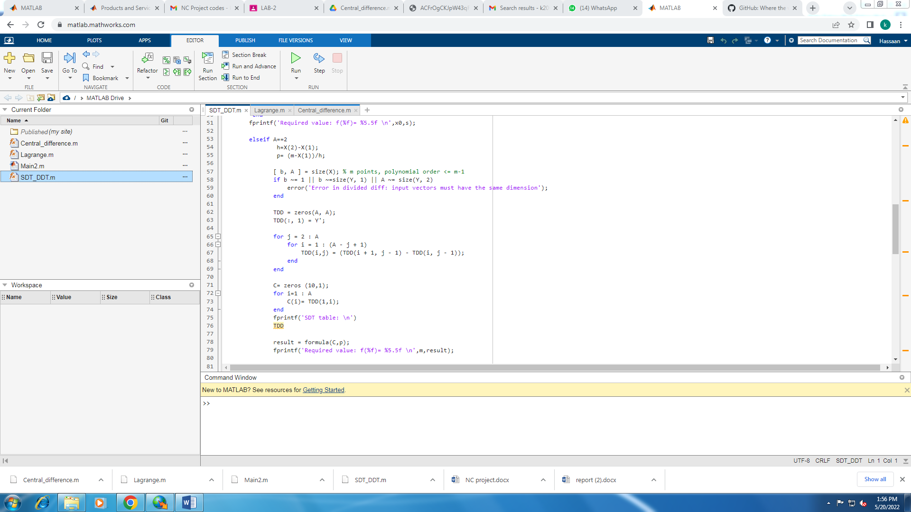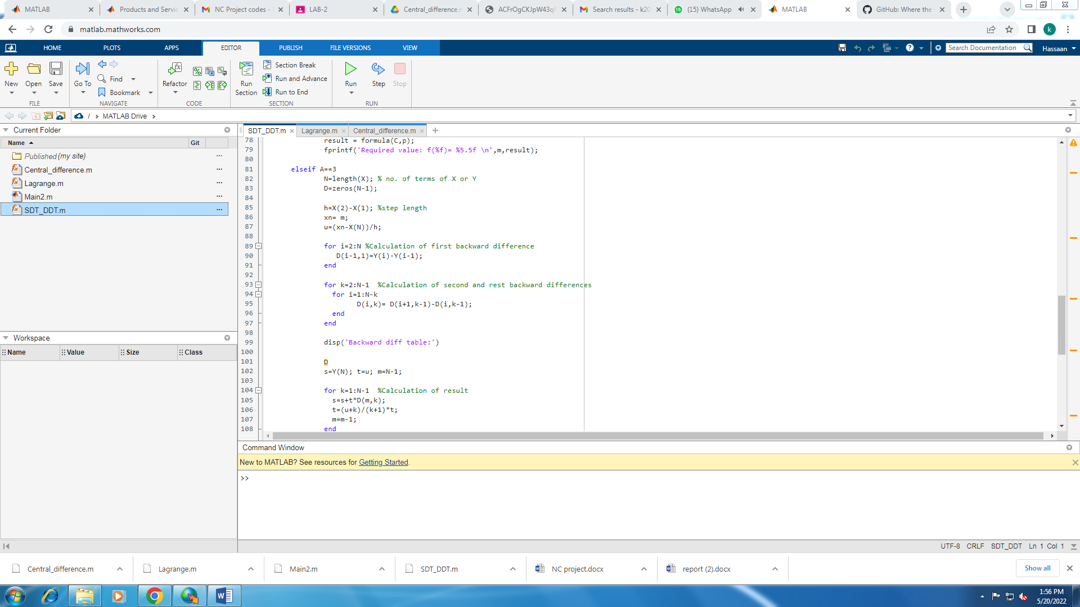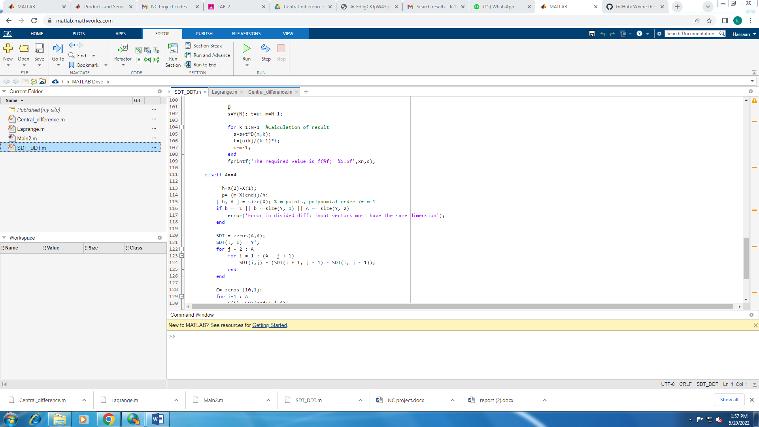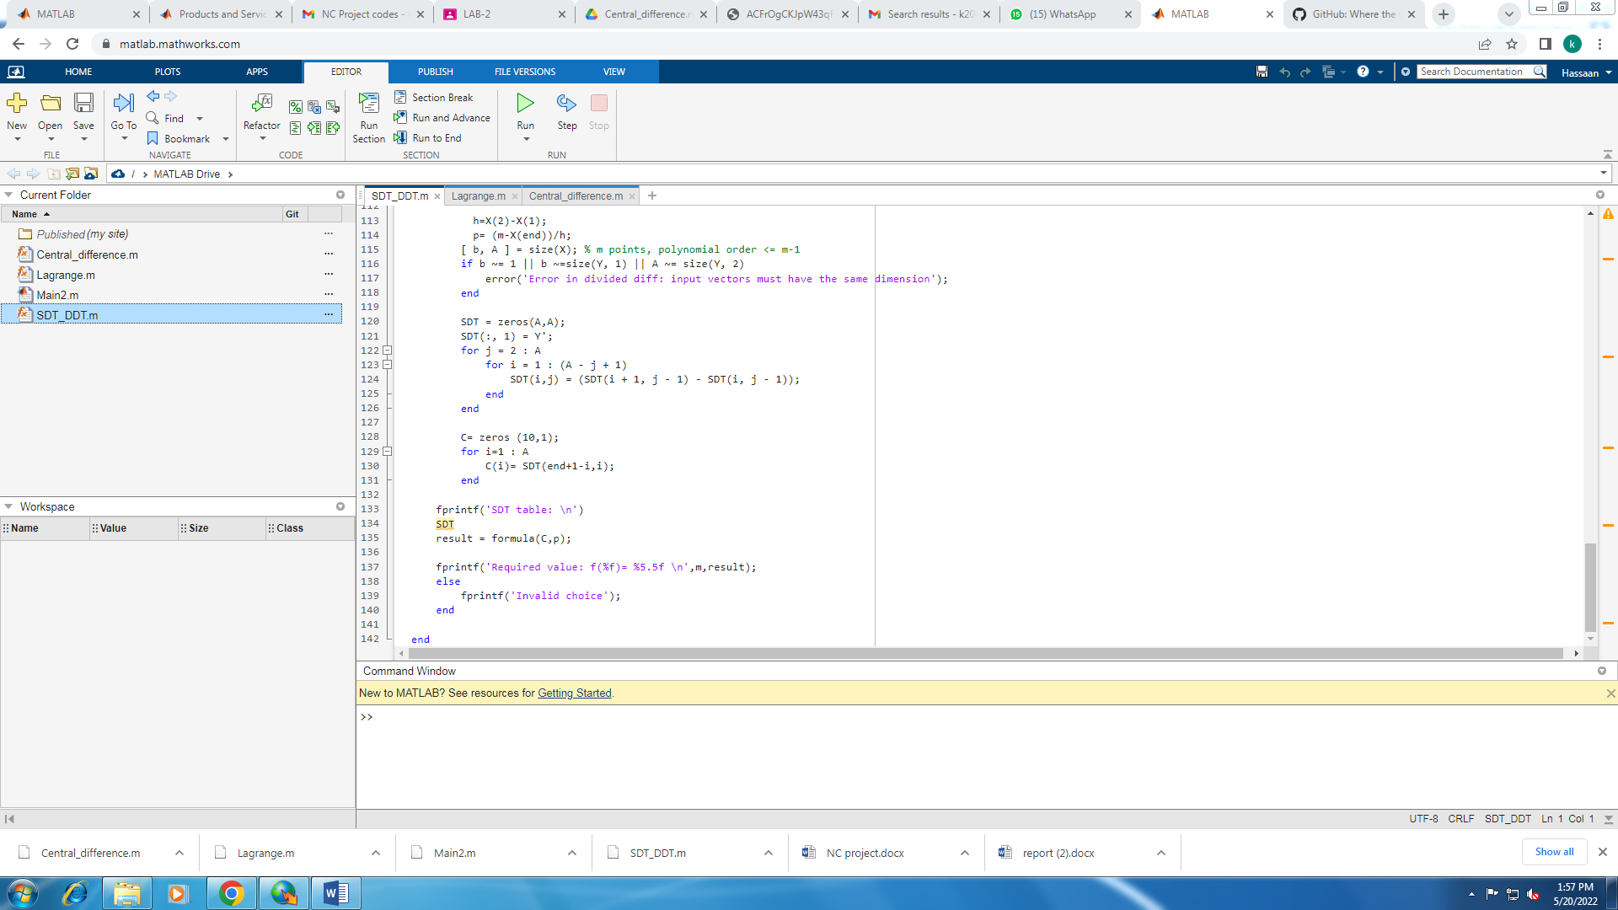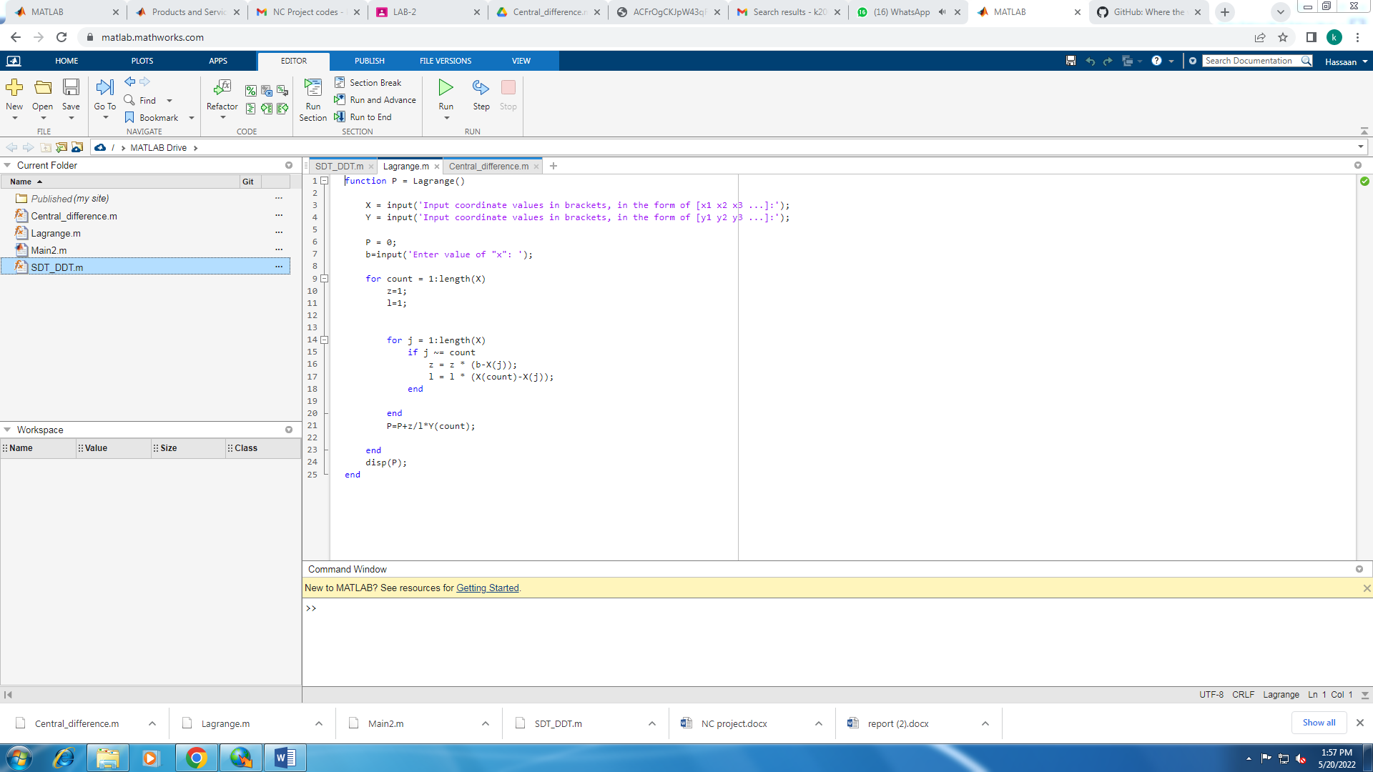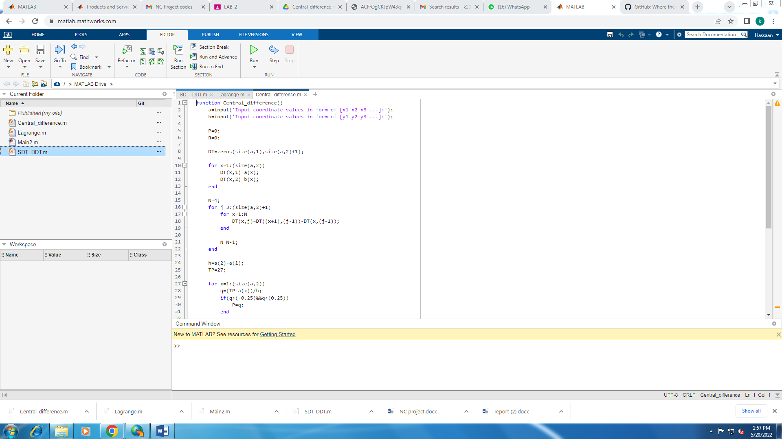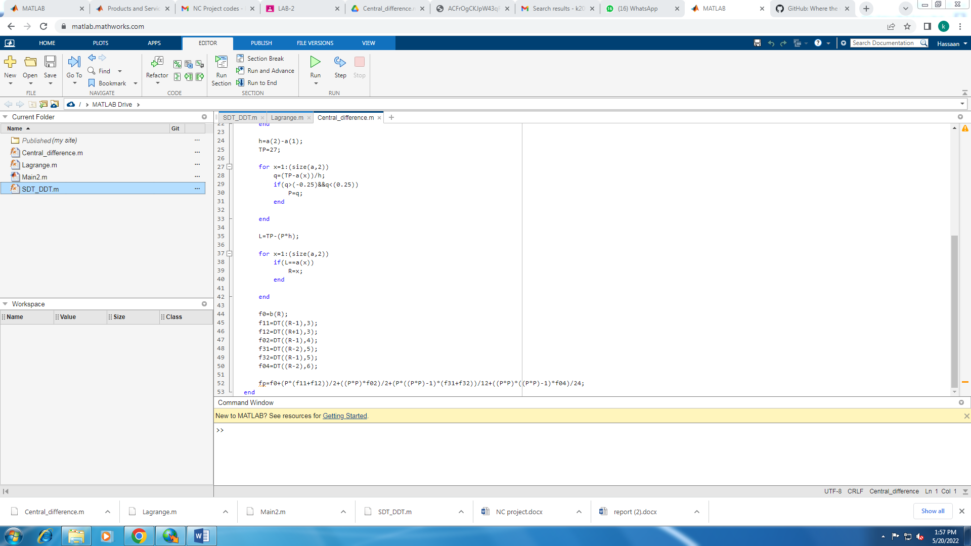

Lab 4: 

 

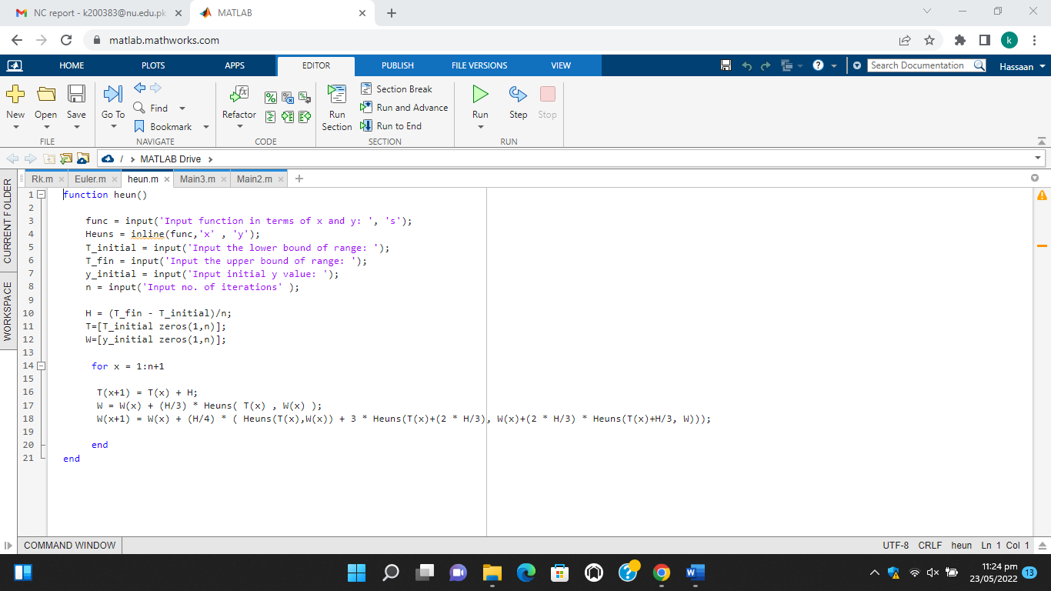

# Analysis between different methods:

## 1. METHODS FOR SOLUTION OF NON LINEAR EQUATIONS:

In conclusion, our tests suggest that the numerical methods with respect to convergence rate; from highest to lowest is as follows Newton method, Secant method, Regula Falsi, Bisection.

## 2. Algorithm METHODS FOR interpolation:

In conclusion our tests suggest that, with Newton interpolation, we got the coefficients quite fast. Hence proving that Newton is a more efficient and better way for interpolation.

## 3. Algorithm FOR Solution of ordinary diffrential equations:

In conclusion our tests suggest that when that when only a few values of Xn are required, Runge Kutta method techniques provide a better result in faster time, however when many values of Xn are required, Euler method is more preferable.